**Dialogs**

1. A dialog is a small window that prompts the user to make decision or enter additional information.
2. On button click we add a dialog having negative and positive buttons

Text

Description generated with very high confidenceText

Description generated with very high confidence

Graphical user interface, application

Description generated with very high confidenceGraphical user interface, application, Teams

Description generated with very high confidence

1. We can also define custom dialogs
2. First we have to create a layout for our dialog box.

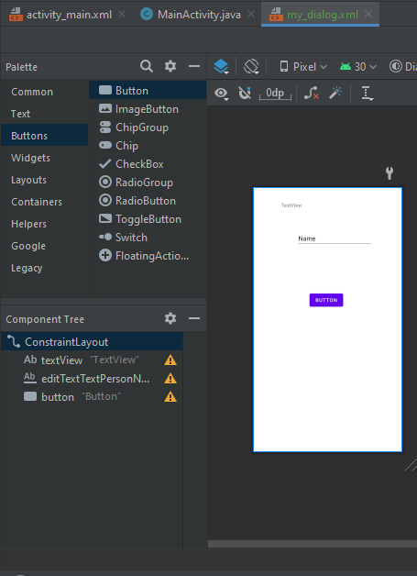

1. Now we add the view in dialog using inflater



1. We get following custom layout on our dialog